Can Machine Learning Predict How a Student will Do in Class?
  - A data science project about what student behaviors matter

Why This Matters
Grades are usually treated as the final outcome, but by the time a student gets a low grade, it’s often too late to help them.
If we can identify patterns early, like low attendance or not studying enough, then educators could step in before students fall behind. This project isn’t just about prediction; it’s about understanding behavior and improving outcomes.

Why I Picked this
I was browsing datasets on Kaggle and found one with about a million student records. The features were pretty simple, how many hours students studied each week, their attendance and how much they participated in class, and it also included the final grade.
At first, my question was kind of basic “Can machine learning predict a student’s final grade? But after getting feedback from my peers, I realized a better question was “Which behaviors actually affect how well a student does and by how much?

The Dataset
The dataset had 1,000,000 students, and each record included:
- Weekly study hours (0–40)
- Attendance percentage (50–100%)
- Participation score (0–10)
- Total score (9.4–100)
- Final grade (A, B, C, D, F)
One thing I noticed right away was that the data was not balanced. Most students had A’s and B’s and F’s were super rare. This matters because a model could just predict “A” most of the time and still look accurate. I focused on precision, recall and F1 score to get a better picture of performance.
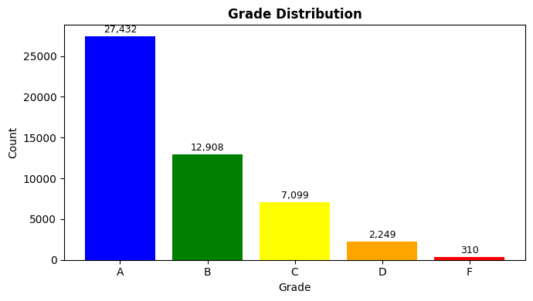
How the Grades Separate by Feature
I plotted each feature split by grade to see if there were differences between grade groups.
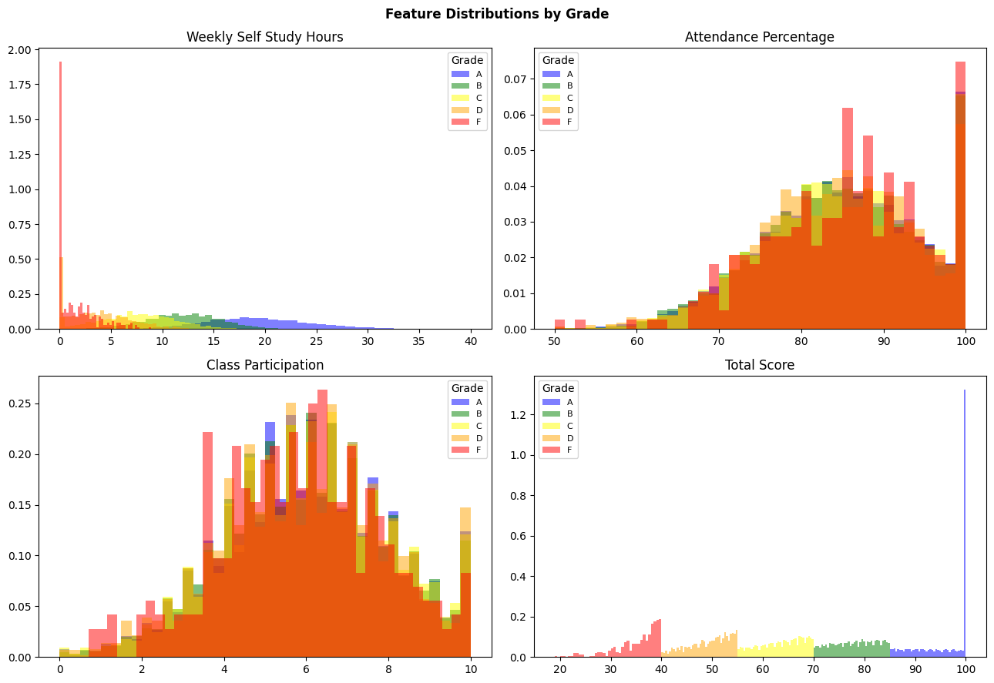

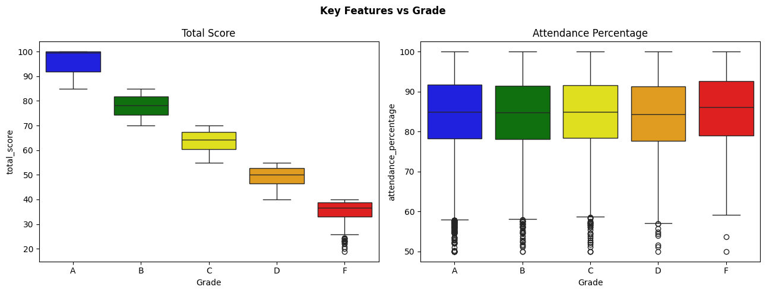
Total score shows the most obvious separation, which makes sense since the grade is calculated directly from it. Attendance and study hours also show clear trends, higher attendance and more study hours strongly correlate with better grades. Class participation had less separation between grades, but it still added value to the models.

The models I tried
I compared three models:
- Logistic Regression – It assumes a roughly linear relationship between features and grades. Great for understanding what is happening but not always the most accurate.
- Random Forest – builds hundreds of decision trees and takes a vote. Really good at picking up patterns that are not perfectly linear
- AdaBoost – I originally wanted to try Gradient Boosting because it usually performs well, but it was taking way too long to train on this dataset, so, after speaking with Daniel, I switched o AdaBoost instead which is a similar idea but runs much faster. It ended up being the best performing model, which was nice.
What the models found
Model | Accuracy | Precision | Recall | F1 | CV F1
Logistic Regression | 0.9785 | 0.9793 | 0.9785 | 0.9787 | 0.9801 ± 0.0019
Random Forest | 0.9977 | 0.9977 | 0.9977 | 0.9977 | 0.9979 ± 0.0006
AdaBoost | 0.9984 | 0.9984 | 0.9984 | 0.9984 | 0.9981 ± 0.0003

All three models did well.

ADABoost hit 99.84% accuracy with a cross validation F1 of 0.9981, which is consistent. Even Logistic Regression at 97.85% is impressive. I also used 5-fold cross validation which splits the data 5 different ways and averages the scores. This is more trustworthy than a single train/ test split because it shows the model performs consistently and not just lucky on one particular split.

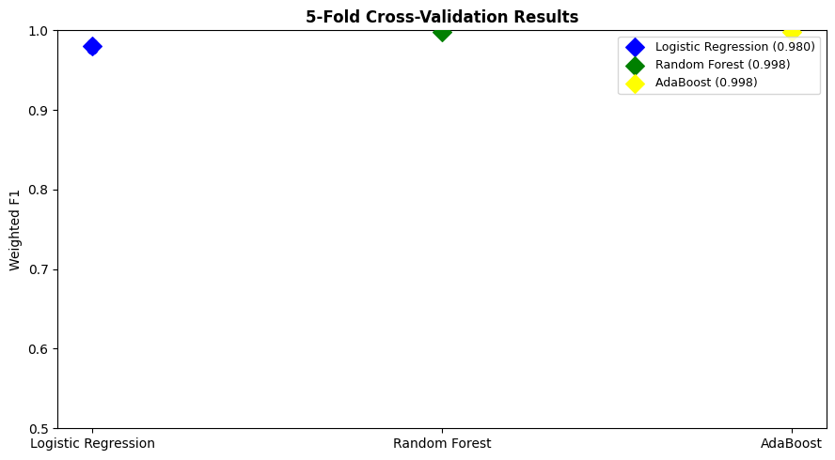

Confusion Matrices
The confusion matrices break down which grades the model gets right and which ones it confuses.
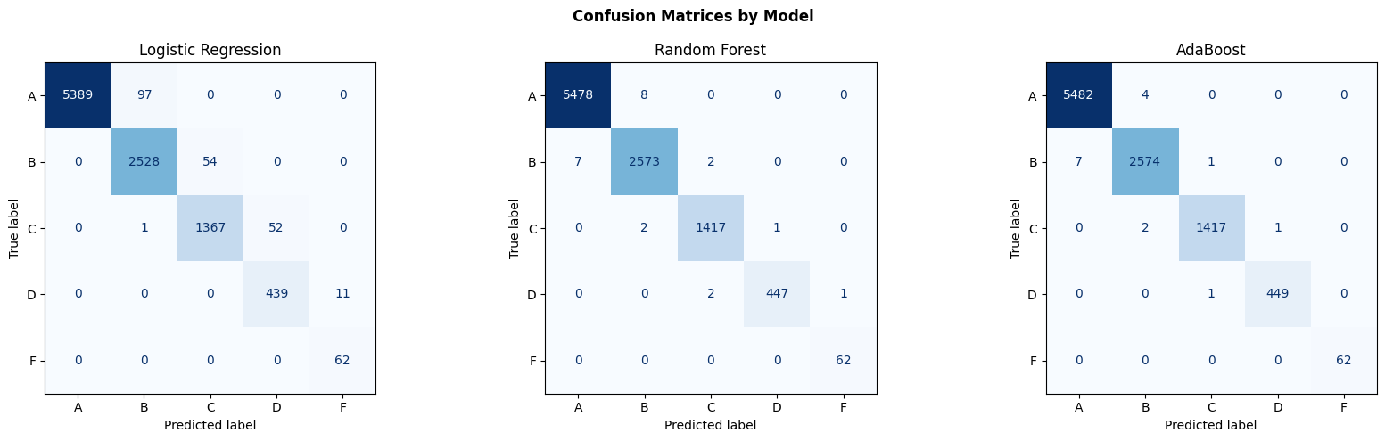
The diagonals are all the correct predictions. What is interesting is that even for the rarest grade “F”, AdaBoost got them all right with zero misclassifications. Logistic Regression made the most mistakes, mostly confusing B’s with A’s and C’s with B’s which makes sense since those grades are adjacent.

What features matter most?
Random Forest tells you directly how much each feature contributes to its predictions.
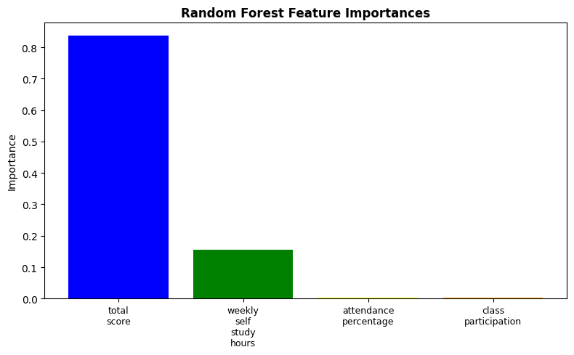
“total_score” is by far the most important feature. Grades are directly calculated from the score, so the model might just be learning the grading formula rather than anything about student behavior specifically. If I were to redo this, I’d try removing total_score and seeing how well the behavioral features alone can predict grades. After total score, study hours came next, then attendance. Class participation had the lowest importance which surprised me a little.

Takeaway
The models performed very well, but the results need some nuance. A lot of that performance probably comes from total_score being basically the same as grade. The more real insight from this project is that attendance and studyhours are the strongest behavioral predictions of academic performance, even when you account for everything else.
For educators, the practical use case is not predicting grades, it is identifying students early who might struggle. Someone with low attendance and few study hours might be heading towards a D or F before it shows up on their transcript. That is exactly why a model like this could actually be useful.

What I learned:
- Accuracy is misleading on imbalanced data. I had to use precision, recall and F1 to really understand what was happening.
- Data exploration matters before modeling. I jumped into training first and only caught the class imbalance issue when I went back and looked at the distribution.
- Practical tradeoffs are real. Gradient Boosting is theoretically strong but I could not use it here because it was too slow. AdaBoost gave me almost the same result in a fraction of that time.
- Cross validation builds trust. A single train/test split is easily to get lucky on. Running 5 folds and getting consistent results game me much more confidence the model actually works.

References & AI Transparency
- Dataset: student_performance.csv —dataset from Kaggle, 1,000,000 student records.
- Libraries used: scikit-learn, pandas, numpy, matplotlib, seaborn.
- AI tools: Claude (Anthropic) was used to help with code structure and debugging.

